Introduction

Prototype system components

E-paper display

Information available at: <http://www.waveshare.com/4.3inch-e-paper.htm>

Support information available at: <http://www.waveshare.com/wiki/4.3inch_e-Paper>

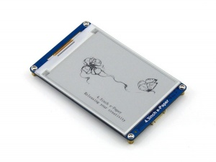

Development board

Although the wiki website recommended a variety of development boards, it is more useful to use a development board with easy access to USB interface. It is recommended to use the FRDM-KL25Z by Freescale for this reason.

Information on the board: <http://www.freescale.com/tools/software-and-tools/hardware-development-tools/freedom-development-boards/freedom-development-platform-for-kinetis-kl14-kl15-kl24-kl25-mcus:FRDM-KL25Z>

The IDE used to develop this board is Kinetis Design Studio which does not have code size restrictions.

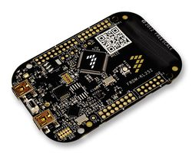

Android plat form

Recommended android plat form must have USB Host capability which is only available from version 3.1 or above.